Write a Prolog Program for PLANETS DB.

**AIM:**

To write a Prolog program that stores and retrieves information about planets, including their distance from the Sun, number of moons, and type.

**ALGORITHM:**

1. Start the program.
2. Define facts in the form planet(Name, DistanceFromSun, Moons, Type).
3. Load the program into the Prolog interpreter.
4. Query the database to retrieve details based on planet name, type, or conditions (e.g., moons > 10).
5. Prolog will return the matching results.
6. Stop.

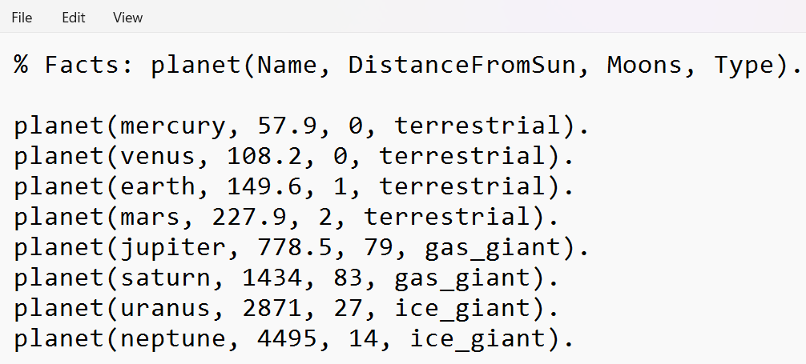

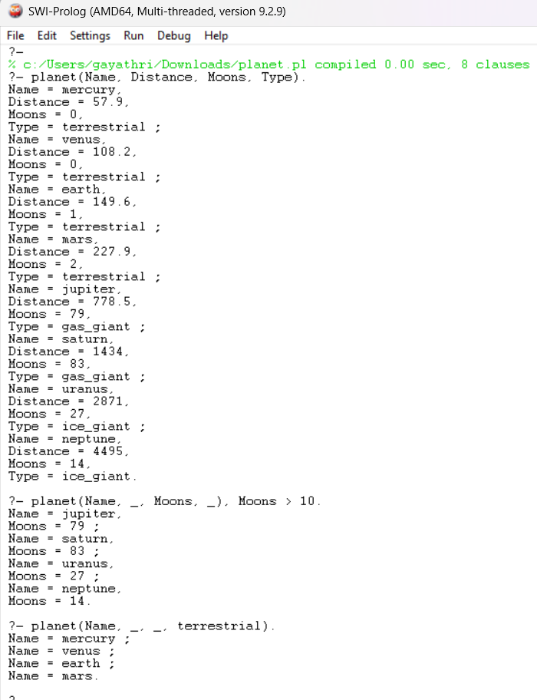

**RESULT:**

The program successfully stores and retrieves planetary information such as name, distance, moons, and type from the knowledge base.